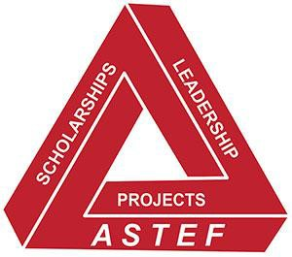
ALPHA STATE TEXAS EDUCATIONAL FOUNDATION

What is ASTEF?
- ASTEF is a 501(c)(3) public charity organized for the following purposes:
  - To provide funding for activities that support professional and personal growth of women educators in Texas, and
  - To promote educational excellence for Texas students
- ASTEF is the fundraising entity supporting the Texas State Organization of Delta Kappa Gamma.

Who runs ASTEF?
- All members of the Texas State Organization of Delta Kappa Gamma are members of ASTEF. The Annual Meeting of members is held during the TSO Convention.
- ASTEF is managed by a Board of Directors elected by the members during the ASTEF Annual Meeting. The TSO President, TSO Treasurer, Scholarship Chair, and Leadership Seminar Chair all serve as ex-officio members of the ASTEF Board. Officers are elected by the Board.

What does ASTEF do?
- ASTEF manages three funds. Scholarship, Leadership and Projects.
- The Scholarship Committee awarded scholarships and lifelong learning opportunities in the amount of $20,250 in 2023.
- The Leadership Seminar Committee provides leadership training through Leadership Seminars and sponsors speakers.
- Projects provide stipends for projects and supports endeavors that benefit Texas students and educators.
- ASTEF awarded $12,000 to aspiring educators and $36,703.90 in project stipends in 2023.

How can members and chapters support ASTEF?
- Contribute to ASTEF. Contribution forms are available online. Contributions may be made in honor or in memory of someone, and all individual contributions are tax deductible to the fullest extent of the law. Be sure you signify to which fund you want your donation to go.
- Participate in ASTEF fundraising activities, such as, Weekender trips, raffles, events, and more.
- Apply for a state scholarship; encourage Aspiring Educators to apply for funding; Participate in TSO Leadership events sponsored by ASTEF; apply for a chapter, individual, or area project stipend. The next application deadline is April 1, 2024.

ASTEF: Impacting Education by Impacting Educators
PO Box 797787 www.astef.org
Dallas, TX 75379-7787 Revised, August, 2023

