Newsletter Masthead or Header Design Elements

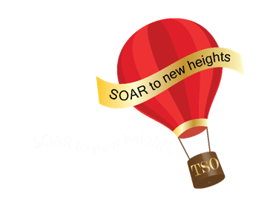 | Lambda Informer  Lambda Chapter 11, Area 8, Temple, Belton, Salado  The Delta Kappa Gamma Society International,  Texas State Organization  Mission Statement: The Delta Kappa Gamma Society International promotes professional and personal growth of women educators and excellence in education.  Vision Statement: Leading women educators impacting educators worldwide.  Betty Beta, editor, bbTSO@hgmail.com

Volume 92, No 1 September 2024

Masthead or Header once designed remains unchanged except for volume number, (number of years chapter has published a newsletter) issue number (restarts at #1 at the beginning of the year) and date (changes monthly or by the issue). Volume 92 = age of chapter No 6 = number of issues

These elements are required, regardless of trying for 5 Star Status. Make sure you check each issue before sending.

The header or masthead needs basic information. The arrangement of the elements is the decision of each chapter; however, the simpler the design, the easier to manage.

Required Information at the top of first page:
- Title of newsletter: Informer
- Chapter name and chapter number
- Location of chapter: city or county served
- Chapter Area Number
- The full name of the Society: The Delta Kappa Gamma Society International
- The state organization: Texas State Organization
- Mission Statement: The Delta Kappa Gamma Society International promotes professional and personal growth of women educators and excellence in education.
- Vision Statement: Leading women educators impacting education worldwide.
- Name of newsletter editor, her email address
- Volume #, Issue #
- Date of Issue

Optional, but encouraged
- DKG logo/graphic: Keypin, Crest, rose, Texas shape of rose
- Current President’s logo/graphic: hot air balloon

